No public access for the bucket as only the instances with the correct permissions are supposed to access this bucket:

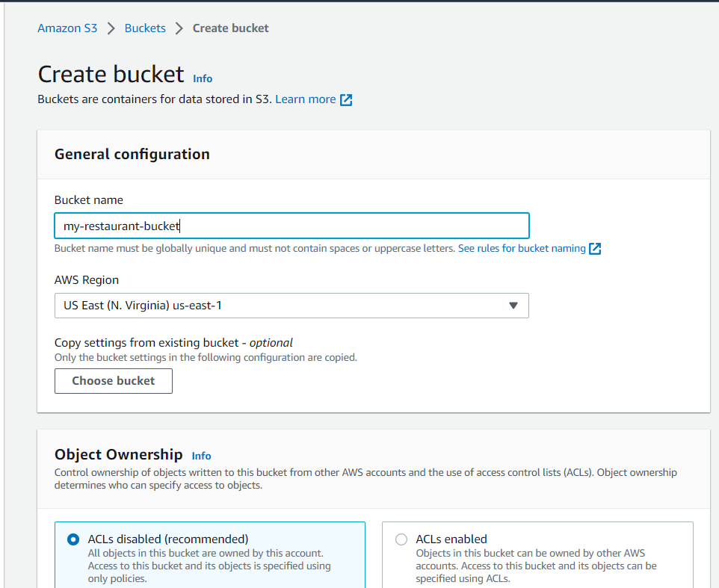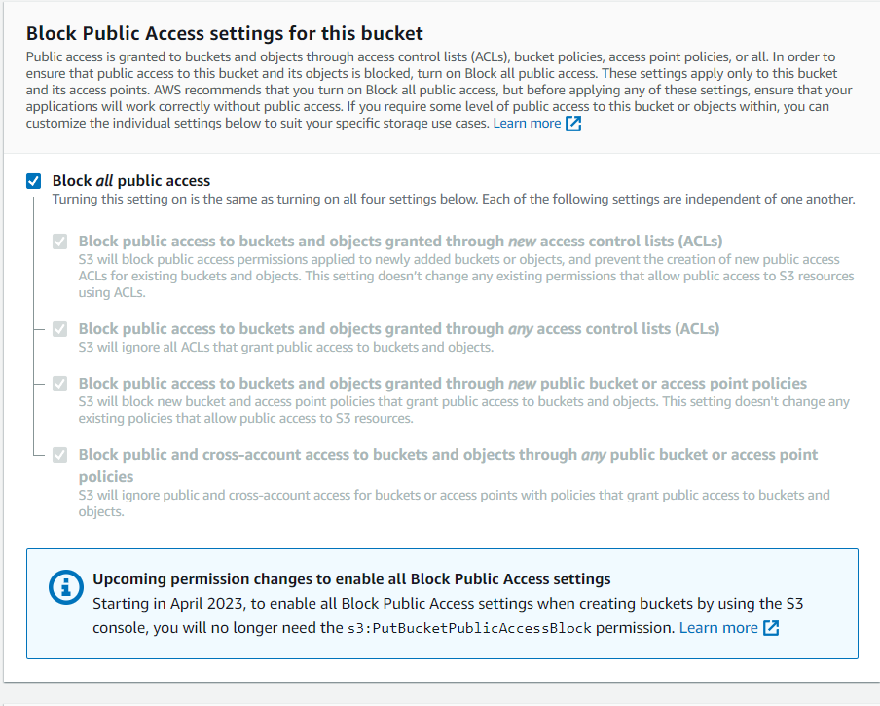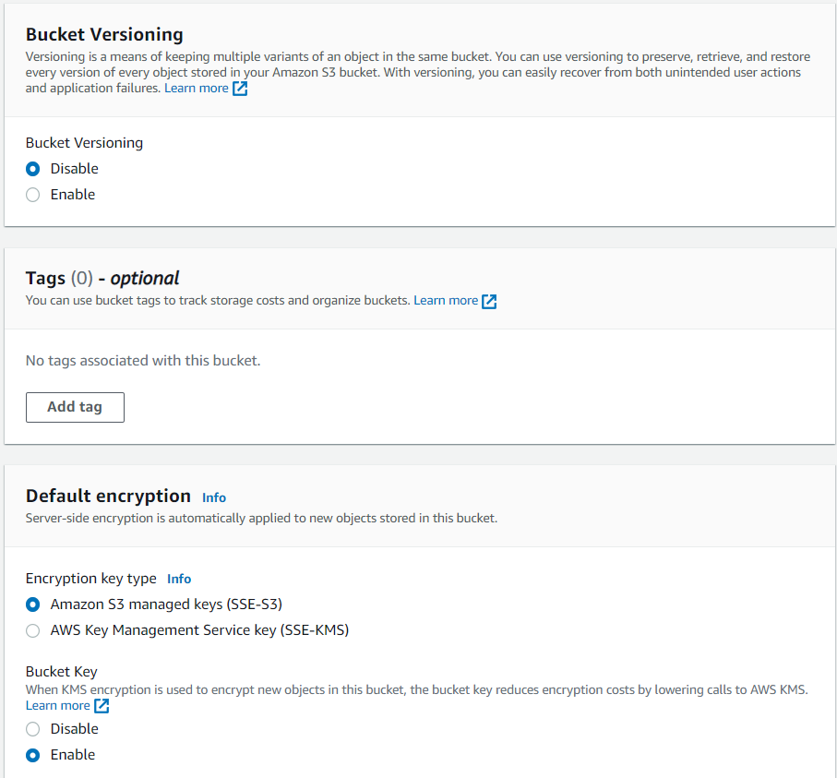

The contents of VeganStudioSourceCode\v5 need to be uploaded into the bucket. Note that db.php will undergo some changes after the RDS is setup.

